# ANALYTICS TOOLS FOR E-COMMERCE BUSINESS

Analytics is the interpretation of data patterns that assist decision-making and performance improvement. Internet has transformed E-Commerce and customer now have access to wide range of products offered through E-Commerce websites. In order to remain competitive and defend market share, E-Commerce firms formulates online marketing strategies based on real time data. This has steered to a paradigm shift in the E-Commerce, where data is seen as a biggest asset to the firm in understanding specific needs of customers, predicting behavior, tailoring specific needs and offering performance metrics to assess effectiveness. For this IBM Cognos is used. IBM Cognos visualize and report on data create powerful visualizations, tell the story of your data and share insights via email, Slack, or the mobile app.

**Keywords**: Data analytics, IBM Cognos, IBM Cloud, IBM Watson.

# I.INTRODUCTION

### MOTIVATION:

For the E-Commerce firms, to grow and sustain, a potential way to create business value is through use of big data applications which can be grouped in personalization, dynamic pricing, customer service, predicting customer behavior, supply chain visibility, and managing fraud. In addition, a firm with strong customer orientation is therefore considered to outpace its rivals since it better recognizes customer needs, regulates products and services, and therefore encounters customer needs. In the recent past, many organizations have moved to online environment to achieve better growth, earn further profits and get closer to their customers by knowing them better. E-Commerce firms are using several online tools to enable online marketing strategies, strengthen customer engagement (using Web analytics tools), Social Media monitoring, Web Content Management systems and Customer Engagement Management.

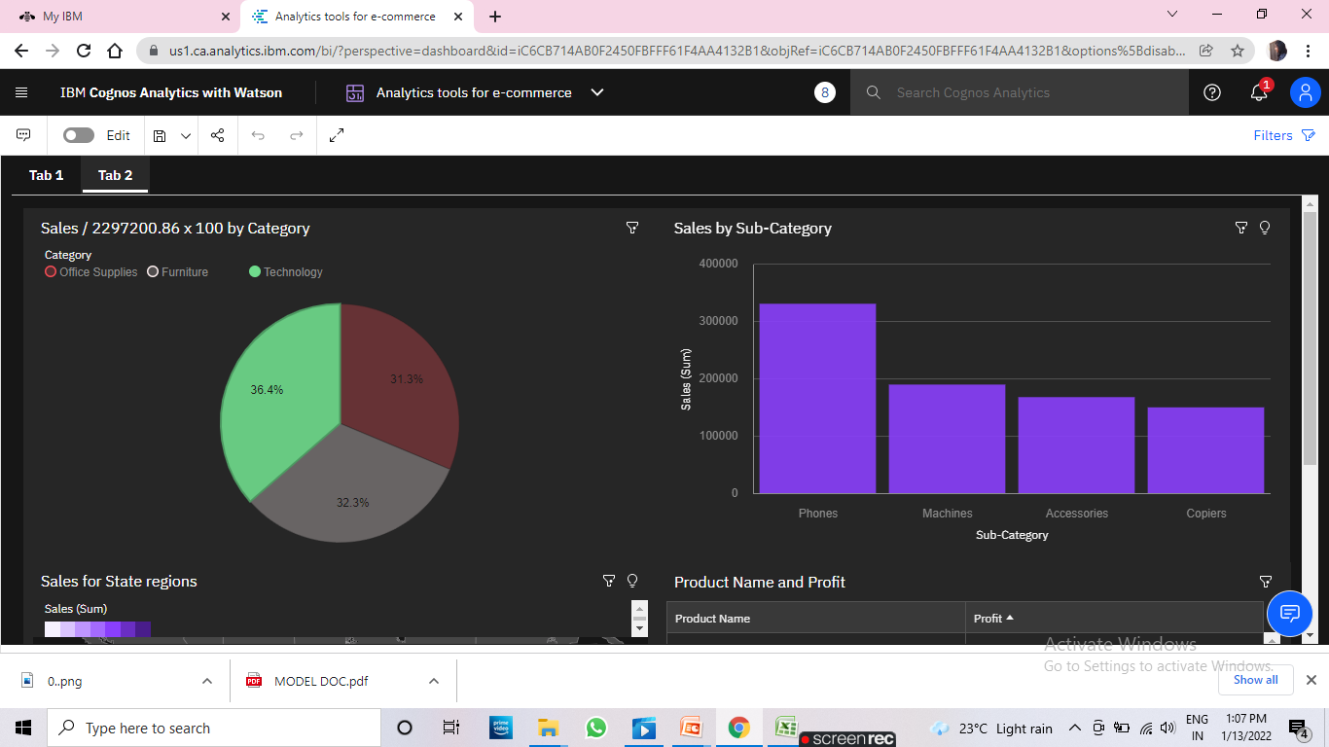

Fig1:Sample Data Visualization

The representation of this data is done using different graphs and different charts. This helps in visualizing the data in an easy manner and represents the data in an accurate way.

This project is purely involves IBM Cognos, Cloud and Watson studio.

### PROBLEM DEFINITION:

### 

Our Problem Statement deals with “Data analytics”.With the increase in consumer demand, the E-commerce space has boomed. This also led to an increase in fierce competition in today's online marketplace.

The e-commerce industry sells a diverse product line of grocery items and merchandise products, such as food, pharmaceuticals, apparel, games and toys, hobby items, furniture, and appliances.

The analysis of such an industry is of great importance as it gives insights into the sales and profits of various products.

IBM Cognos take the data input and visualizes the data and represent the data in pictorial representations like graphs and charts and gives the clear survey about the clean water and sanitation at different areas across the state.

### OBJECTIVE OF THE PROJECT:

The progress in machine learning and IBM cloud has contributed to unprecedented improvement in computer vision. IBM Cognos import data from csv files and spreadsheets and quickly create compelling, interactive dashboards. Drag and drop data to create auto-generated visualizations. Therefore, in this literature IBM Cognos is used to perform visualization of the data. The main objective of the project is that to represent the data about the amount of water present in the respected geographical areas.

### LIMITATIONS OF PROJECT:

limitations are as follows:

* + - The total Cost of Ownership (TCO) is more significant than other tools at IBM Cognos.
    - The forecast capabilities are very minimal at IBM Cognos.
    - Investment in Cognos R&D by IBM is declining.
    - IBM Cognos doesn’t work smoothly with large data sets having many parameters.
    - Cross-browser compatibility is often problematic at IBM Cognos.
    - Suppressing the aggregated values can slow down performance sometimes.
    - Using concurrent query execution might speed up a report, but It is also possible that it could slow it down.
    - Cognos will only suppress individual records that are zero.

### ORGANIZATION OF DOCUMENTATION:

Analytics Tools for E-Commerce Business helps to find out many variations that has occurred in the business. It also helps in finding the growth of company. This will help us to find the profit and loss without making much effort. This is the easiest way for dealing with the profits and loss calculations. It will save your time. The aim of this study was to determine the time and resources required to document.

The majority (54 %) of documentation was done by experts, 62 % of all documentation involved persons. The results of different scenarios for the representation of data, and follow-up of end users.

# II.LITERATURE SURVEY

### INTRODUCTION:

The online marketing space is in constant shift as new technologies, services, and marketing tactics gain popularity and become the new standard. Online store owners are one of the many different segments affected by these constant evolutions. In order for these business owners to survive and thrive, they need to be able to make better decisions faster.

This is where web analytics comes into play. Having access to statistical information from all areas of your online marketing and sales activities gives you an advantage over competitors that do not have this information. Understanding trends and which marketing channels are no longer profitable allows you to maneuver as a business before damage is done to your bottom line.

And, understanding shifts in consumer behavior gives you insights into the demands of your market. Knowing these things enables you to drop certain products or make strategic changes in your pricing that will result in big gains or, at the very least, limit damage to your profits.

### EXISTING SYSTEM:

### What is E-commerce? Definition, Models, Types, Categories, Benefits, Challenges - The Investors Book

### Fig 2: Existing Problem

## Existing problem How can you reveal the data needed from a complex data?

**Methods or approaches:-**

1. **Grouping manually and analyzing:-** We have to group the data manually that is needed, and this process takes more time and in the middle we have to modify with some more data then we have start this process from the beginning which take more efforts and time
2. **By using Dashboard:-**

**Makes the complex simple:-** We have lots of information, lots of data that changes all the time and different analytical needs and questions we can take all this complexity and make it simple.

Tells a clear story, We want to be able to connect data to its context in the business and to answer the viewer's questions. This is where the visual layout of a dashboard plays a crucial role

**Expresses the meaning of the data:-** The chosen data visualizations need to correctly represent the data and the information you want to extract from.

**Reveals details as needed:-** The viewer can access to the data they need no less but also no more.

### DISADVANTAGES OF EXISTING SYSTEM:

1. There are also a couple of disadvantages, since E-Commerce deal with huge amount of sensitive and confidential data, security and privacy are two main concerns.
2. Any analytics system which handles this data must be designed to prevent any unauthorized access. There have to be multiple levels of access and the system must be constantly monitored for any data theft.

3. Maintaining such a system will obviously lead to greater costs and that's the second main disadvantage to implementing e-commerce analytics.

4. High acquisition and maintenance costs mostly act as a detorrent, especially for smaller companies to implement such a system. Also, operating a sophisticated analytics tool requires special expertise and that results in additional training costs, or the costs of hiring an IT expert to handle this system.

### PROPOSED SYSTEMS:

**IBM Watson studio (IBM Cognos):**

In vision of the problem statement described in the introduction section, an IBM Watson studio platform (IBM Cognos) is used represent the datasets of availability of water present at different states and different regions across the country. The framework is composed of the following important phases:

* Dataset Collection.
* Data Preprocessing.
* Creating folders.
* Visualize the data.
* Representation of the collected data.
* Graphical representations.
* Pictorial representations.

Classifications of the data sets are done on the basis of specific properties possess by the sample variable is capable to classify them. These data samples have the data regarding their particular state wise allocation release of water and quality affected habitations and water contamination. Designed platform is first takes the dataset and the user can represent the data accordingly. IBM Cognos Analytics integrates reporting, modeling, analysis, dashboards, stories**,** and event management so that you can understand your organization data, and make effective business decisions. After the software is installed and configured, administrators set up security and manage data sources.

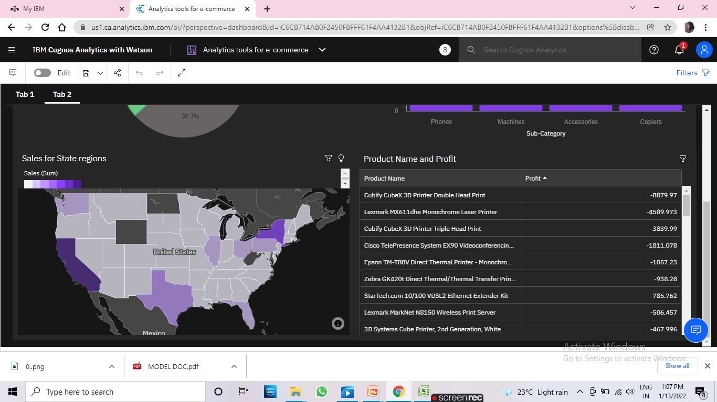

**Fig.3:** Cognos sample output.

### CONCLUSION:

# The Refined date is used to plot graphs with various comparisons in each tab. o These tabs are moved to a single tab to create a Final Dashboard.

# And in the Final Dashboard we can see the filter that can be applied and see the statistics in between our given combinations.

1. **ANALYSIS**

### INTRODUCTION:

While selecting the API that gives the accurate output, we gone through a lot of API’s which gives the results abruptly accurate and from them we selected only one API for the representation and visualization of data that is IBM Cognos, it assumes that the data to be presented in a way that is easily understandable to everyone. In contrast to a [user interface,](https://en.wikipedia.org/wiki/User_interface) which connects a computer to a person, an application programming interface connects computers or pieces of software to each other. In building applications, an API (application programming interface) simplifies programming by [abstracting](https://en.wikipedia.org/wiki/Abstraction_(software_engineering)) the underlying implementation and only exposing objects or actions the developer needs. While a graphical interface for an [email client](https://en.wikipedia.org/wiki/Email_client) might provide a user with a button that performs all the steps for fetching and highlighting new emails, an API for file [input/output](https://en.wikipedia.org/wiki/Input/output) might give the developer

a [function](https://en.wikipedia.org/wiki/Subroutine) that copies a file from one location to another without requiring that the developer understand the [file system](https://en.wikipedia.org/wiki/Journaling_file_system) operations occurring behind the scenes.

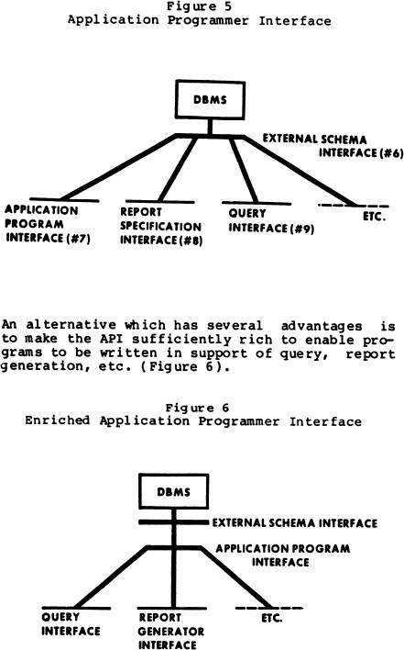

**Fig.4:** Application interface proposed model.

### SOFTWARE REQUIREMENT SPECIFICATION:

The software requirements specification document lists sufficient and necessary requirements for the project development. To derive the requirements, the developer needs to have clear and thorough understanding of the products under development. This is achieved through detailed and continuous communications with the project team and customer throughout the software development process.

Software requirements specification is a rigorous assessment of requirements before the more specific system design stages, and its goal is to reduce later redesign. It should also provide a realistic basis for estimating product costs, risks, and schedules. Used appropriately, software requirements specifications can help prevent software project failure.

### User requirement:

* + - A dashboard is a visual display of all of your data. While it can be used in all kinds of different ways, its primary intention is to provide information at a glance, such as KPIs
    - Dashboards allow all kinds of professionals the ability to monitor performance, create reports and set estimates and targets for future work.
    - A dashboard usually sits on its own page and receives information from a linked database. In many cases it's configurable, allowing you the ability to choose which data you want to see and whether you want to include charts or graphs to visualize the numbers.All the data is collected in excel sheets and presented.

### Software Requirement:

* + - * IBM Watson studio Environment.
      * IBM Cognos.

We developed this API at IBM Cognos. Firstly, we had collected the dataset in the excel sheets format then that data is visualized at IBM Cognos, IBM Watson studio. Then the data is represented using bar graphs, Pie charts any many more representations. It does not require any other independent libraries or any other extra frame works to access the output.

### Hardware Requirement:

* + - * System: 64-bit windows 10
      * RAM:4GB
      * Processor:2.3GHz

### CONTENT DIAGRAM OF PROJECT:

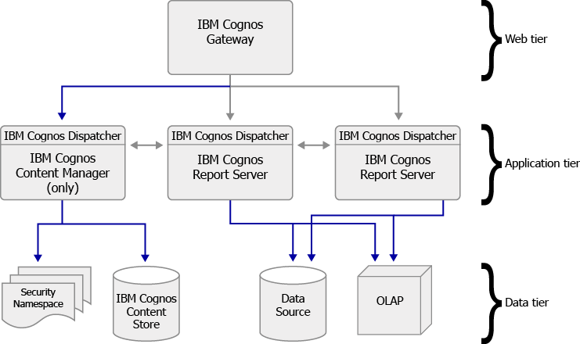

**Fig.5:** Content diagram of API.

### ALGORITHMS ANDFLOWCHARTS:

In this paper, IBM Cognos is used to represent the data. Data is visualized and represented. IBM Cognos platform is used to represent the data in an accurate manner. There is no special algorithm is used in this project.

### Flowcharts:

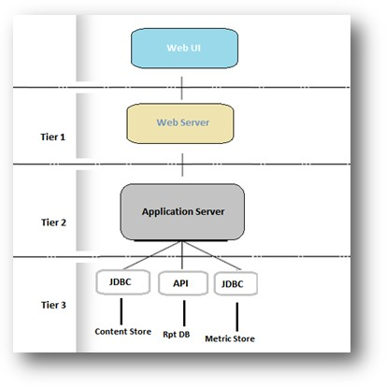

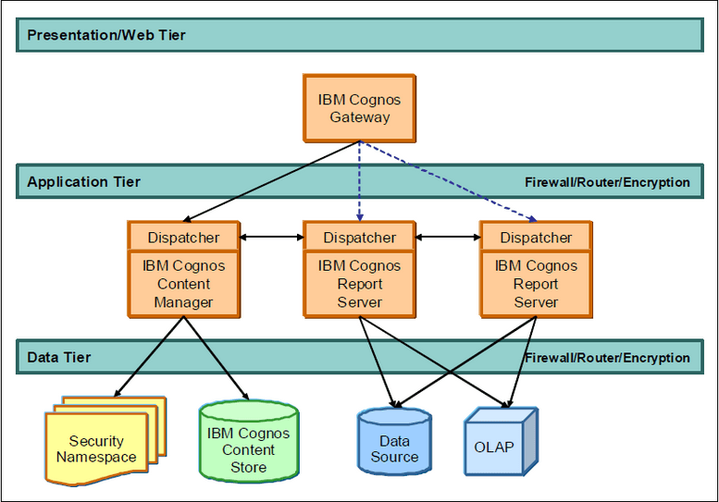

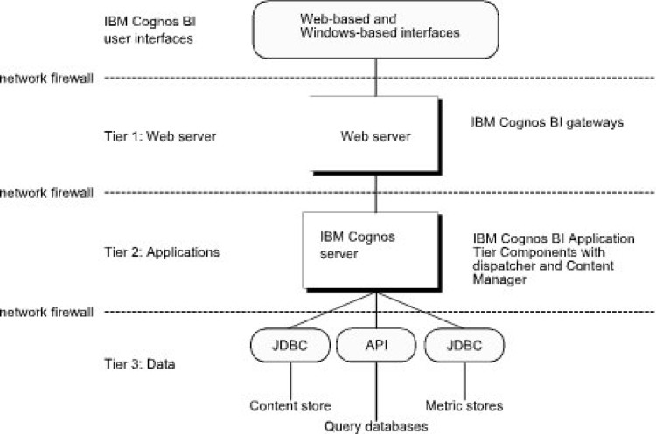

### CONCLUSION:

Making use of the prior computer technology we have successfully found a platform that can actually visualize the given dataset correctly in order to make use of the platform correctly and also to know the accurate amount of water present across the country and its usage.

## DESIGN

* **IBM Cognos Architecture:**

IBM Cognos Business Intelligence has a multitiered architecture. For description purposes, it can be separated into three tiers: Web server, applications, and data. The tiers are based on business function, and are typically separated by network firewalls. IBM Cognos BI user interfaces sit above the tiers. Let’s go step by step through all these tiers.

### [User Interfaces](https://www.ibm.com/docs/en/SSEP7J_10.2.2/com.ibm.swg.ba.cognos.crn_arch.10.2.2.doc/c_arch_userinterfaces.html#arch_UserInterfaces)

IBM Cognos BI is configured using IBM Cognos Configuration. You also use IBM Cognos Configuration to start and stop IBM Cognos services.

### [Tier 1. Web Server: IBM Cognos BI Gateways](https://www.ibm.com/docs/en/SSEP7J_10.2.2/com.ibm.swg.ba.cognos.crn_arch.10.2.2.doc/c_arch_cognos8gateways.html#arch_Cognos8Gateways)

The IBM Cognos BI Web server tier contains one or more IBM Cognos BI gateways.

### [Tier 2. Applications: IBM Cognos BI Servers](https://www.ibm.com/docs/en/SSEP7J_10.2.2/com.ibm.swg.ba.cognos.crn_arch.10.2.2.doc/c_arch_tier2.applications.html#arch_Tier2.Applications)

The IBM Cognos BI applications tier contains one or more IBM Cognos BI servers. An IBM Cognos BI server runs requests, such as reports, analyses, and queries, that are forwarded by a gateway. An IBM Cognos BI server also renders the IBM Cognos Connection and Metric Studio interfaces.

### [Tier 3. Data: Content Providers](https://www.ibm.com/docs/en/SSEP7J_10.2.2/com.ibm.swg.ba.cognos.crn_arch.10.2.2.doc/c_arch_tier3.data.html#arch_Tier3.Data)

The IBM Cognos Business Intelligence data sets.

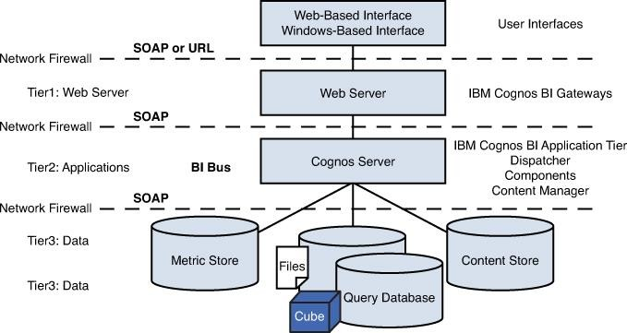

**Fig.6:** Fine architecture of IBM Cognos.

### DFD DIAGRAM:

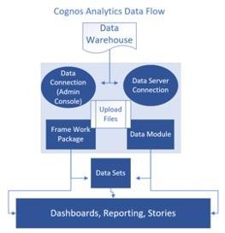

### ORGANIZATION OF DATA:

In this project the datasets are taken in excel sheets. And then they are visualized at IBM Cognos dashboard.

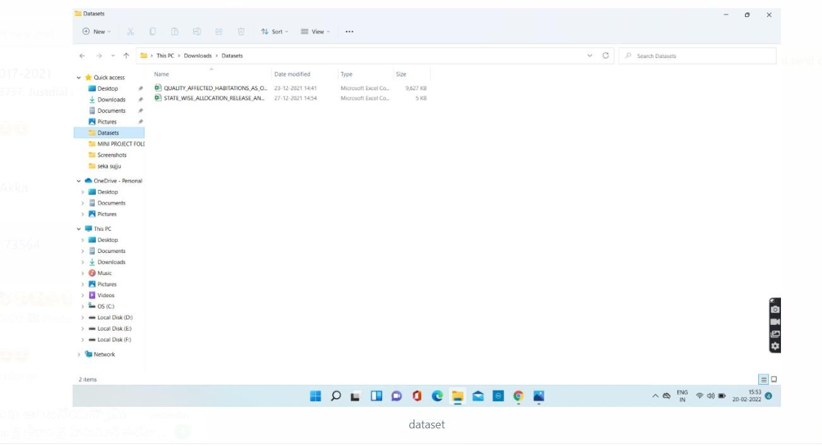

**Fig.7:** model folders

### CONCLUSION:

The dashboard of IBM Cognos is used to visualize the data that is present in the datasets and gives the accurate output.

## IMPLEMENTATION AND RESULTS

### INTRODUCTION:

In this paper various platform dashboards are used for the implementation of the dataset but the most suitable platform is IBM Cognos. To get the most from IBM® Cognos® Business Intelligence, you must implement it effectively. This means installing and configuring IBM Cognos BI so that it integrates with your information technology infrastructure and meets your reporting requirements.

To plan an effective IBM Cognos implementation, do the following:

* + - Familiarize yourself with the IBM Cognos BI architecture.

For more information, see the architecture section of this document.

It will help you understand the components that make up IBM Cognos BI, their functions, and the ways in which they interact with each other, your infrastructure, and your authors and users.

* + - Decide how to install and configure IBM Cognos BI.

Know what your options are for installing and configuring IBM Cognos BI, and decide which best meet your needs. For more information,

see [installation options.](https://www.ibm.com/docs/en/SSEP7J_10.2.2/com.ibm.swg.ba.cognos.crn_arch.10.2.2.doc/c_arch_installationoptions.html#arch_InstallationOptions)

* + - Decide how to maximize IBM Cognos BI performance in your environment.

Understand the factors that can affect IBM Cognos BI performance, and plan to ensure and maintain Options. Adequate capacity, scalability, and availability for IBM Cognos BI in your environment. For more information,

see [performance Planning.](https://www.ibm.com/docs/en/SSEP7J_10.2.2/com.ibm.swg.ba.cognos.crn_arch.10.2.2.doc/c_arch_performanceplanning.html#arch_PerformancePlanning)

* + - Decide how to configure IBM Cognos BI multilingual capabilities.

If you will use IBM Cognos BI in a global environment, decide how to configure IBM Cognos BI so that interface elements and report contents appear in the languages that users need. For more information, see [globalization considerations.](https://www.ibm.com/docs/en/SSEP7J_10.2.2/com.ibm.swg.ba.cognos.crn_arch.10.2.2.doc/c_arch_globalizationconsiderations.html#arch_GlobalizationConsiderations)

### EXPLANATION OF KEY FUNCTIONS:

The main key function which is used in this project is visualization of the

data.

* + - Implementation of data.
    - Visualization.
    - Output.

### 5.3 CONCLUSION:

The main aim of this project is to know the accurate amount of the profit over the years in the country and how it can be used for better purposes.

1. **CONCLUSION**

# From the above report we can conclude that the overall performances at different departments can be displayed and can be understandable by seeing the Dashboard.

# In this project we have to create a IBM Cloud Account and login to the IBM Cognos Analytics.

# Then, we have to upload the Dataset of Analytics tools for e-commerce business and understand the data and refine it without having any null values.

# After the sorting the dataset with some calculations and formulae we can start our visualization techniques.

# This whole ideal form is to make the job easy for E-Commerce firms by introducing Analytics in there area.

### Future Enhancement:

The future work will focus on exploring more of the dataset values and yielding more interesting outcomes. This study can help in making more effective and reliable data presentations. In further study, we will try to conduct experiments on larger data sets or try to tune the data so as to achieve even more better performance of the API and a great UI support system.

# OUTPUT SCREENS

# Order by Region Colored by Region:

# 1.png

# Profit by Product Name:

# 2.png

# Sales by Year:

# 3.png

# Row ID and Category:

# 4.png

# Sales and Profit by Year:

# 5.png

# Sales by 2297200.86 x 100 by Category:

# 6.png

# Sales by Sub-Category:

# 7.png

# Sales for State Regions:

# 8.png

# Product Name and Profit:

# 9.png

### 7.1 RESULT ANALYSIS:

### The results screens above shows the Profits and losses in different states across the country. It also represents the sales for the region and sales in the year. It also represents the products that were bought profit to the company in the different years.

# CONCLUSION

# From the above report we can conclude that the overall performances at different departments can be displayed and can be understandable by seeing the Dashboard.

# In this project we have to create a IBM Cloud Account and login to the IBM Cognos Analytics.

# Then, we have to upload the Dataset of Analytics tools for e-commerce business and understand the data and refine it without having any null values.

# After the sorting the dataset with some calculations and formulae we can start our visualization techniques.

# This whole ideal form is to make the job easy for E-Commerce firms by introducing Analytics in there area.

# APPLICATION

* E-Commerce executives need to be able to quickly review and analyze all critical KPIs in one place. This example displays high-level metrics such as order by region and by location and key ratios such as sales and profit.

# Measure the effectiveness of your marketing and sales campaigns. Data analytics can assist ecommerce companies in measuring how successful their marketing campaigns are, as well as improving decision-making, gaining more omni channel traction, and informing holistic marketing programs.

* Ecommerce analytics is the process of accumulating data from all of the areas that have an impact on your store. You should then use this data so that you can comprehend shifts in customer behavior and online shopping trends.
* Ultimately, you can make more intelligent decisions by basing them on data, which should result in more online sales being made.
* Ecommerce analytics can include a wide range of metrics relating to the full customer journey, such as discovery, acquisition, conversion, retention and advocacy.
* There is only one place to begin, and this is with data analytics that pertains to your audience. This will give you in-depth insights regarding the demographics of your audience, i.e. their gender, age, income, occupation, where they are based and what language they speak.
* Ecommerce analytics give you the power to get a better understanding of how your business is performing now and how it is likely to perform in the future. This forecasting will inform everything from hiring goals and sales goals to making sure that the right products are accessible at the right time so that your customers’ expectations are met.

# With ecommerce analytics, you are going to be able to benefit from a granular picture of what drives pricing for every consumer segment. You can use this insight so that you are able to discover the best price points at the product level, rather than category level, so you can earn optimal revenue.

* Understanding how customers interact with your business is imperative to inform what sort of formats, content and channels appeal to and resonate with your target demographics. You can use ecommerce data analytics to help optimally position your products and improve the purchasing journey for all of your customers.

# Another benefit that is associated with ecommerce analytics is that you will be able to inform your strategy by using data analytics. This will give you great insight into what is happening within your business and the industry as a whole so you can figure out some vital market trends and possible risks that you need to mitigate.

# ADVANTAGES

* It detects and correct the errors from data sets with the help of data cleansing. This helps in improving quality of data and consecutively benefits both customers and institutions such as banks, e-commerce and finance companies.
* Precise analysis thanks to the use of data and relevant metrics.
* A good basis to write other key reports and recommendations:
* These benefits make the Analytics dashboard an essential tool to help with decision making. Indeed, it provides an accurate, real-time overview of the current situation of e-commerce Businesses. Data and insights make it possible for to define a coherent strategy to take actions that will be grounded in the reality experienced by operational teams.

# DISADVANTAGES

1. There are also a couple of disadvantages, since E-Commerce deal with huge amount of sensitive and confidential data, security and privacy are two main concerns.
2. Any analytics system which handles this data must be designed to prevent any unauthorized access. There have to be multiple levels of access and the system must be constantly monitored for any data theft.
3. Maintaining such a system will obviously lead to greater costs and that's the second main disadvantage to implementing e-commerce analytics.

High acquisition and maintenance costs mostly act as a detorrent, especially for smaller companies to implement such a system. Also, operating a sophisticated analytics tool requires special expertise and that results in additional training costs, or the costs of hiring an IT expert to handle this system.

# FUTURE SCOPE

# From the various sources of secondary data on E – Commerce trends, it is found that Information technologies have changed the ways of doing business and disrupted many business value chains.

# Customer Centric approaches (product designs, pricing), collaborative web content, globalization, big data analytics are some of the emerging paradigm shift in E Commerce.

# The impact of Social commerce and Ubiquitous (Mobile) commerce on E – Business and especially online purchasing cannot be ignored by both B2C and B2B categories of Business models. Broadly the emerging analytics on E - Commerce can be classified into data analytics, network analytics and mobile analytics.

# The market is flooded with innovative products for managing, processing, and analyzing big data. Big data has helped businesses identify events before they occur (‘predictive analytics').

# Also, successful adoption of advances in technology has played a key role in development of new channels for payment initiation, improved authentication and efficient processing of payment systems.

# IX. REFERENCES

# 1. Hughes JK. Supplying web 2.0: An empirical investigation of the drivers of consumer transmutation of culture-oriented digital information goods. Electronic Commerce Research and Applications. 2010; 9(5):418–34.

# 2. Anderson C. The Long Tail. WIRED Magazine. Available from: http://www.wired.com/wired/archive/12.10/tail.html,Data accessed: 2-2014.

# 3.. Liang TP, Turban E. Introduction to the special issue on social commerce: a research framework for social commerce. International Journal of Electronic Commerce. 2011; 16(2):5–13.

# 4. Wang C, Zhang P. The evolution of social commerce: The people, management, technology, and information dimensions. Communications of the Association for Information Systems. 2012; 31(1):105–27.

# X.HELP FILE

The project is Clean Water and Sanitation, so to build the project we need to follow the following steps:

**STEP 1:**

Collect the datasets for the project from online website( Kaggle etc).

**Step 2:**

Create an IBM Academic Initiative Account and IBM Cognos account.

( https://www.youtube.com/watch?v=x6i43M7BAqE – Referral video for creating IBM Academic Initiative Account)

**Step 3:**

Open IBM Cognos Analytics in Google and login with your IBM Academic Initiative Account.

Then click on Dashboard creation and upload your datasets.

**STEP 4:**

Select a Dashboard design for dashboard creation.

Now by using your datasets and visualizations design as shown select a visualization to display your dataset in a pictorial form.

**STEP 5:**

Same as previous step you can create as many visualization charts as you wish or as you want for your project.

**STEP 6:**

And then you can add any background colors or any changes you need.

# Now the project is finished.